***LINUX EXERCISES - GROUPS AND USERS MANAGEMENT***

*NOTE 1: We have to start a root session to do the exercises*

*NOTE 2: Take into account that user and group names are CASE SENSITIVE*



1. Add two new groups named “daw” and “crey”

**<groupadd daw>**

**<cat /etc/group>**

**<groupadd crey>**

**<cat /etc/group>**









1. Change “daw” and “crey” GIDS to 2001 and 2002, respectively.

**<groupmod -g 2001 daw>**

**<groupmod -g 2002 crey>**

**<cat /etc/group>**





1. Create a new group called “profesores” with GID of 2000. Then, modify the group name to teachers.

**<groupadd -g 2000 profesores>**

**<groupmod -n teachers profesores>**









1. Verify that you have correctly created the groups named “daw”, “crey” and “teachers”

**<cat /etc/group>**





Another way: **grep 2000 /etc/group; grep 2001 /etc/group; grep 2002 /etc/group**

**tail -3 /etc/group** → we are not going to study this, but it also works (-number means the number of lines it will display

→ to enter different users with the command line we can type **<login (username)>** ALWAYS BEING IN THE ROOT (/). If we press exit after login, we logout from that user and go back to the root with the privileged user.

1. Add a new user named “john” whose primary group is “crey”. Has the home directory been created with the default command?

**<useradd -g 2002 -m john>**



**2002 is the ID of the group, but it also works with its name (crey)

Also seen:

**<adduser -ingroup crey john>**

1. Add a new user named “mary”, whose primary group is “daw” and the home directory /home/mary

**<useradd -g 2001 -m mary>**



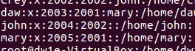

**2001 is the ID of the group, but it also works with its name (daw)

1. Add a new user named “martha”, whose primary group is “teachers”, the home directory /home/martha and belonging to the secondary group “crey”

**<useradd -g 2000 -G 2002 -m martha>**



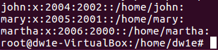

**it also works with their names

Seen for showing the results:

<tail -3 /etc/group>

<grep martha /etc/group>

1. Add the following names to the users that you have just created:

a. John= “John Doe”

b. Mary = “Mary Williams

c. Martha = “Martha Jones”

**<usermod -c “John Doe” john>**

**<usermod -c “Mary Williams” mary>**

**<usermod -c “Martha Jones” martha>**





1. How could you check that you have created all the users with the right primary groups?

**<cat /etc/passwd>**





1. Verify if crey and daw groups have martha as a member

**<grep “crey” /etc/group>**

**<grep “daw” /etc/group>**





1. Can you log in with any of the users you have created?



It is not possible. A password is required.

1. Set the password “martha22” for the user “martha”

**<passwd martha>** **and then we type the password we want to assing

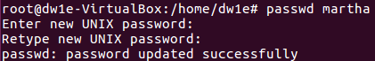

Also seen:

**<openssl passwd -crypt martha22>** → with this we obtain an encrypted password

**<usermod -p** (encrypted_password) **martha>**

1. Display on the shell prompt the groups to which Martha belongs

**<groups martha>**



Also seen:

**<grep martha /etc/passwd; grep martha /etc/group>**

**→** *passwd* is for the primary group

→ *group* is for the secondary ones

1. . Create a directory named “teachers” in “/home”. Then, assign the directory “/home/teachers” to the user martha (you can do all the steps typing just one command).

**<cd /home; mkdir teachers; usermod -d /home/teachers -m martha>**



CORRECTION:



1. Now, log in as user “martha”. Run the command “cd $SHOME” and check that the home directory is “/home/teachers”

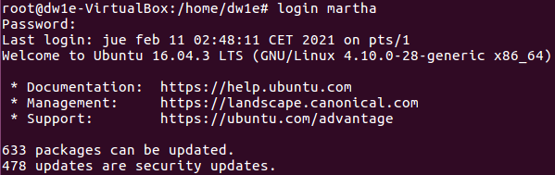

(lots of lines)



***WRONG***

1. . Go back to the root shell

**<logout>**

**<exit>**

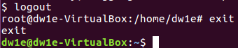

1. Change the shell of the user named “john” to “sh”

**<usermod -s /bin/sh john>**



1. . Add the user “martha” to the secondary group “daw” without removing the already assigned secondary groups.

**<usermod -G daw -a martha>**





1. Run a command to print the following information for each user

**<groups john mary martha>**

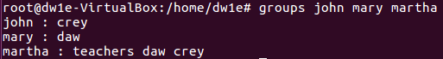

CORRECTION:

**<id john; id mary; id martha>**

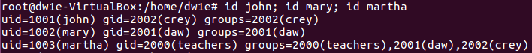

|  |  |  |
| --- | --- | --- |
| **User** | **Primary group** | **Secondary group** |
| john | crey |  |
| mary | daw |  |
| martha | teachers | crey, daw |

1. Delete all the groups you have created. Could you delete them? Why

**<groupdel daw; groupdel crey; groupdel teachers>**

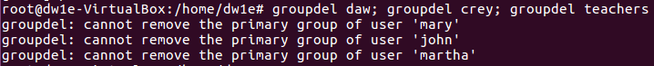

It is not possible because they are primary groups of at least one user.

1. Delete all the users you have created, including the files and directories inside the home.

**<userdel -r john; userdel -r mary; userdel -r martha>**

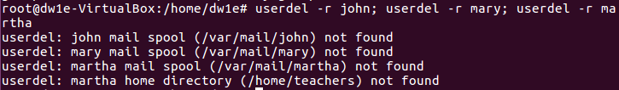

(????)

1. Try again to delete the groups.

**<groupdel daw; groupdel crey; groupdel teachers>**



**ALFREDO PUERTA GALLEGO DW1E**